**U19EC046 | WMC | LAB X**

**AIM**

To Perform QPSK and QAM modulation Techniques using ScienTech Trainer Kit.

**Practical 9.1**

**Aim**

To Perform QPSK modulation Technique using ScienTech Trainer Kit.

**Apparatus**

ST 2112 QAM Trainer Kit

CRO

CRO Probes

**Procedure**

1. Ensure the following initial conditions on ST2112 trainer: Power supply and SW3, SW5, SW6, SW7, SW9 should be in the OFF mode.
2. Switch on the power supply.
3. Connect Test point TP6 on Channel 1 & TP7 on Channel 2 of Oscilloscope; you will observe 1 KHz sine & cosine wave.
4. Set I & Q Channel data with the help of DIP switch SW5, SW6, SW7. As there are 24 bits data available on the trainer so, first bit is I bit then second bit is Q bit then third bit is C bit. But in this experiment you have to use I bit & Q bit so you can select combination according to your requirement.

For example:

SW5=11000010

SW6=01001010

SW7=00100010

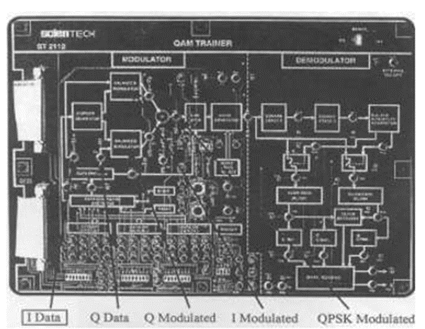

Fig 1. QPSK (Quadrature phase shift keying)

1. Switch ON all the DIP switches on SW3.
2. Now press SW8 which is reset switch then press SW4 which is start.
3. Now connect Channel 1 of Oscilloscope to TP2 & Channel 2 to TP1, you can observe Clock & Data which you have set.
4. Now to observe QPSK modulated signal with respect to data connect Channel 1 to TP1 & Channel 2 to TP8. You can observe QPSK modulated signal with respect to data.
5. Turn OFF the power.

Two 1 KHz sine carriers, shifted between them of 90°, are separately applied to two balanced modulators. The data (signals I and Q) reach the two modulators from the bit generator. Each modulator provides the direct sine-wave when the data signal is to low level (bit “0”), the inverted sine-wave (shifted of 180°) when the bit is “1”. By adding the two outputs you get a 1 KHz sine signal, which phase can take 4 different values separated of 90° between them.

**Block Diagram**

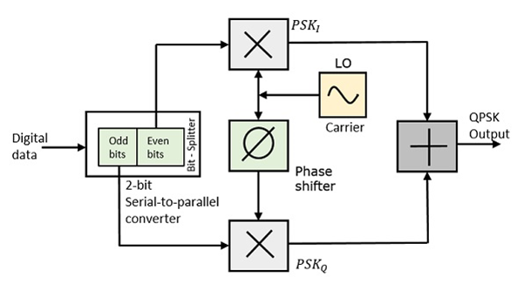

**Waveforms And Constellation Diagram**

*Clock and Data*

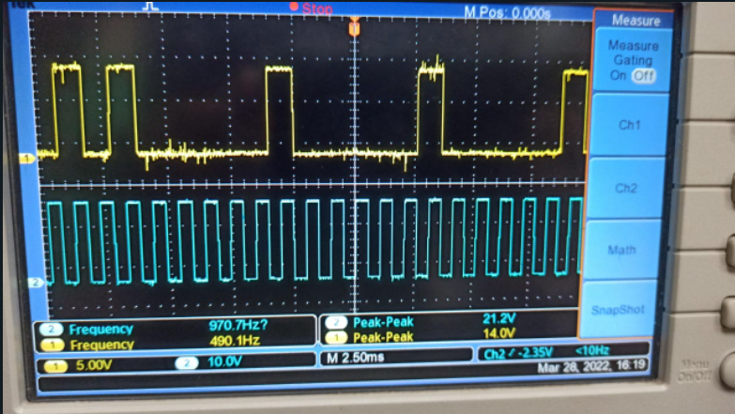

*Data and QPSK*

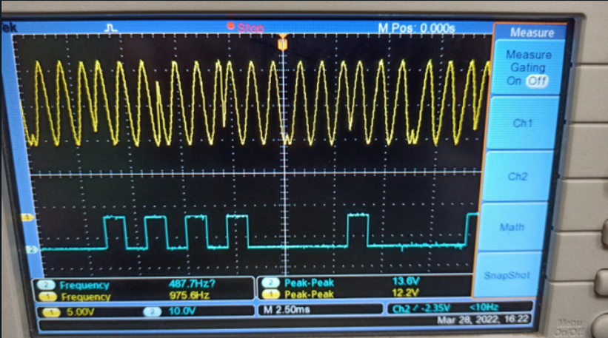

*Input I and Output I(y)*

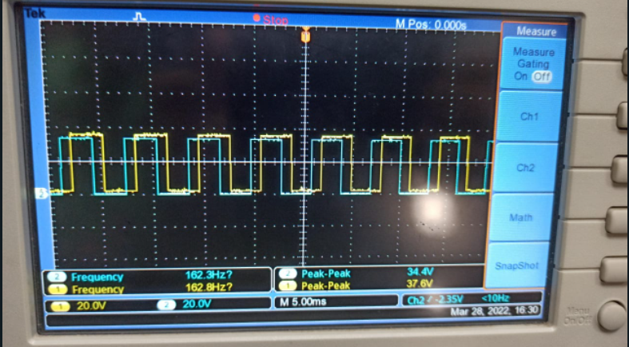

*Input q and Output Q(y)*

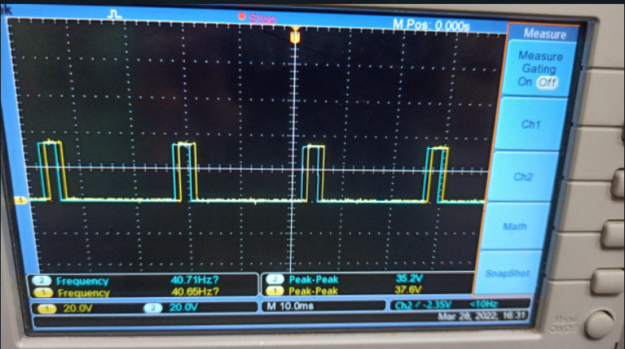

*Constellation Diagram*

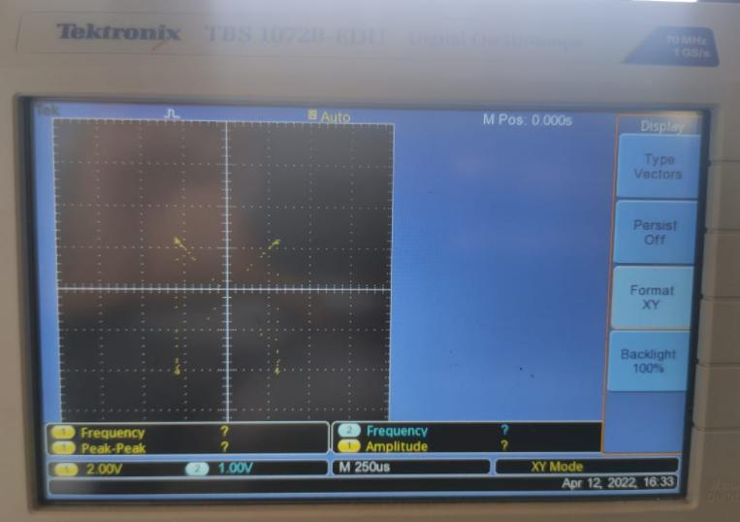

**Conclusion**

In this experiment, we studied and implemented QPSK on ST 2112 QAM Trainer Kit and got the Constellation Diagram on DSO.

**Practical-9.2**

**Aim**

To Perform QAM modulation Technique using ScienTech Trainer Kit.

**Apparatus**

ST 2112 QAM Trainer Kit

CRO

CRO Probes

**Theory**

The QAM is a digital modulation where the information is contained into the phase as well as the amplitude of the transmitted carrier.

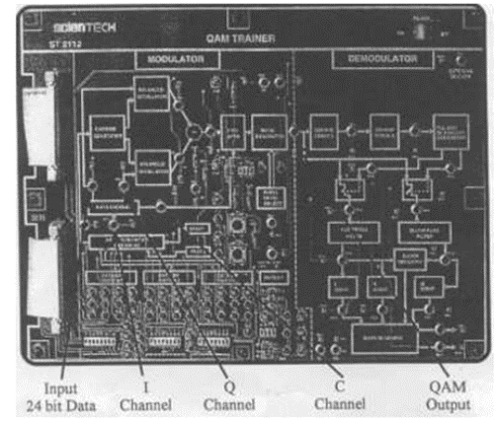

Fig.1 QAM Modulation Kit

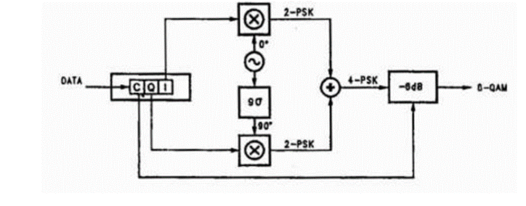

Fig.2 (Block Diagram)

**8-QAM**

In the 8-QAM the data are divided into groups of 3 bits (Tri bit), one of which varies the amplitude of the carrier, the last two the phase. The modulated signal can take 4 different phases and 2 different amplitudes, for a total of 8 different states.

**16-QAM**

In the 16-QAM the data are divided into groups of 4 bits (Quad bit). The 16 possible combinations change amplitude and phase of the carrier, which can take 16 different states.

**Procedure**

1. Ensure the following initial conditions on ST2112 trainer: Power supply and SW3, SWS, SW6, SW7 and SW9 should be in the OFF mode.
2. Switch on the power supply.
3. Connect Test point TP6 on Channel 1 & TP7 on Channel 2 of Oscilloscope; you will observe 1 KHz sine & cosine wave.
4. Set I, Q & C Channel data with the help of DIP switch SW5, SW6, SW7. As there are 24 bits data available on the trainer so, first bit is I bit then second bit is Q bit then third bit is C bit. For example:

SW5=11000110

SW6=01011000

SW7=01100010

1. Switch ON all the DIP switches on SW3.
2. Now press SW8 which is reset switch then press SW4 which is start.
3. Now connect Channel 1 of Oscilloscope to TP2 & Channel 2 to TP1, you can observe Clock & Data which you have set. (If you are using logic analyzer then you are able to see all 24 bits)
4. Now to observe QAM modulated signal with respect to data, connect Channel 1 toTP1 & Channel 2 to TP9.
5. You can add noise by using DIP switch SW9 (001/010/111).
6. To observe the demodulator section, connect channel 1 of oscilloscope to the test point TP 12 you will observe squarer frequency.
7. To observe I switch & Q switch in the demodulator section, connect channel 1 of oscilloscope to TP 16 & channel 2 of the oscilloscope to TP 17.
8. To observe I, Q & C demodulated signal connect oscilloscope to TP 2O, TP 21, TP 22 (if you have logic analyzer you can observe I, Q & C simultaneously).
9. To observe decoded data you have to connect oscilloscope channel 1 to TP 23 & channel 2 to TP 24.
10. Turn OFF the Power.

**Waveforms And Constellation Diagram**

*Data and QAM*

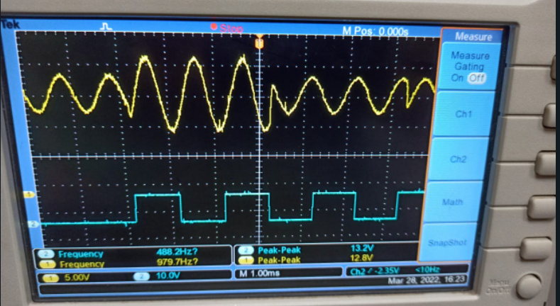

*Constellation Diagram*

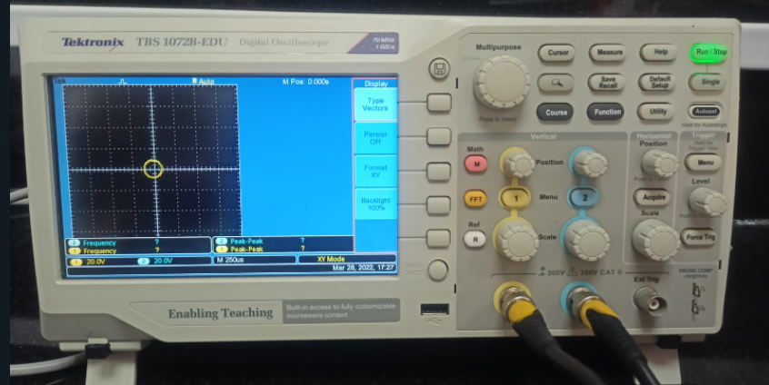

**Conclusion**

In this experiment, we studied and implemented QAM on ST 2112 QAM Trainer Kit and got the Constellation Diagram on DSO